Bryan Jorge
GRC Risk Register Project — Law Firm Simulation
1. Project Overview
This project simulates a full GRC risk assessment aligned with NIST SP 800-30 for a fictional mid-sized law firm. The deliverables include an asset inventory, risk identification, qualitative scoring, treatment planning, and a professionally formatted Excel workbook.
2. Environment Overview
Organization: Hamilton & Cole LLP
Industry: Legal Services
Employees: ~120
Primary systems: Microsoft 365, VPN, Document Management System, HR Database
Security drivers: ABA cybersecurity rules, state privacy laws, GDPR
3. Asset Inventory Summary
Critical assets identified:
- Client case files
- Billing system
- Document management system
- HR records
- Email system
- Attorney laptops
- VPN remote access
Detailed table in Sheet 1.
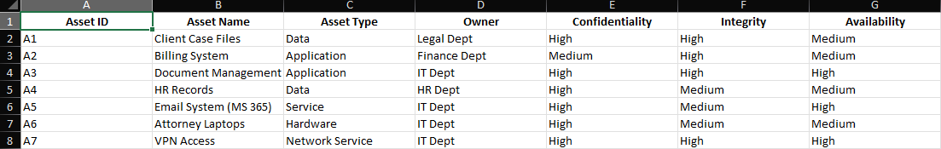
4. Risk Identification Summary
Risks were discovered by mapping assets to threats and vulnerabilities:
- Phishing
- Ransomware
- Device theft
- Data breaches
- Brute-force attacks
- System downtime
Detailed table in Sheet 2.
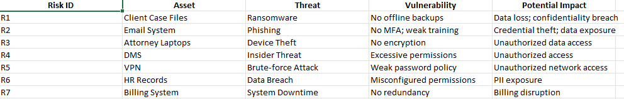
5. Risk Assessment Summary
Risks scored using:
Risk Score = Likelihood × Impact (1–5).
Risk levels:
- Critical
- High
- Medium
- Low
Full scoring and color-coded visualization in Sheet 3.
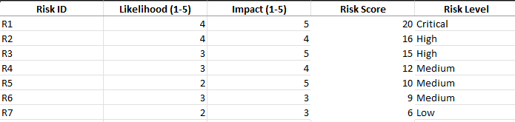
6. Risk Treatment Summary
Mitigation strategies mapped to NIST 800-53 controls:
- MFA
- Encryption
- EDR
- Offline backups
- Least privilege
- Redundancy
Full plan in Sheet 4.
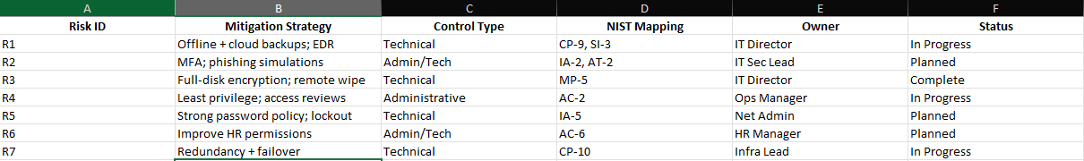
7. Executive Summary
Top risks:
- R1: Ransomware on client files
- R2: Phishing via email system
- R3: Device theft affecting attorney laptops
Recommendations:
- Implement MFA
- Deploy EDR and encryption
- Perform access reviews
- Establish redundancy and backup testing
Full narrative in Sheet 5.
8. Heatmap 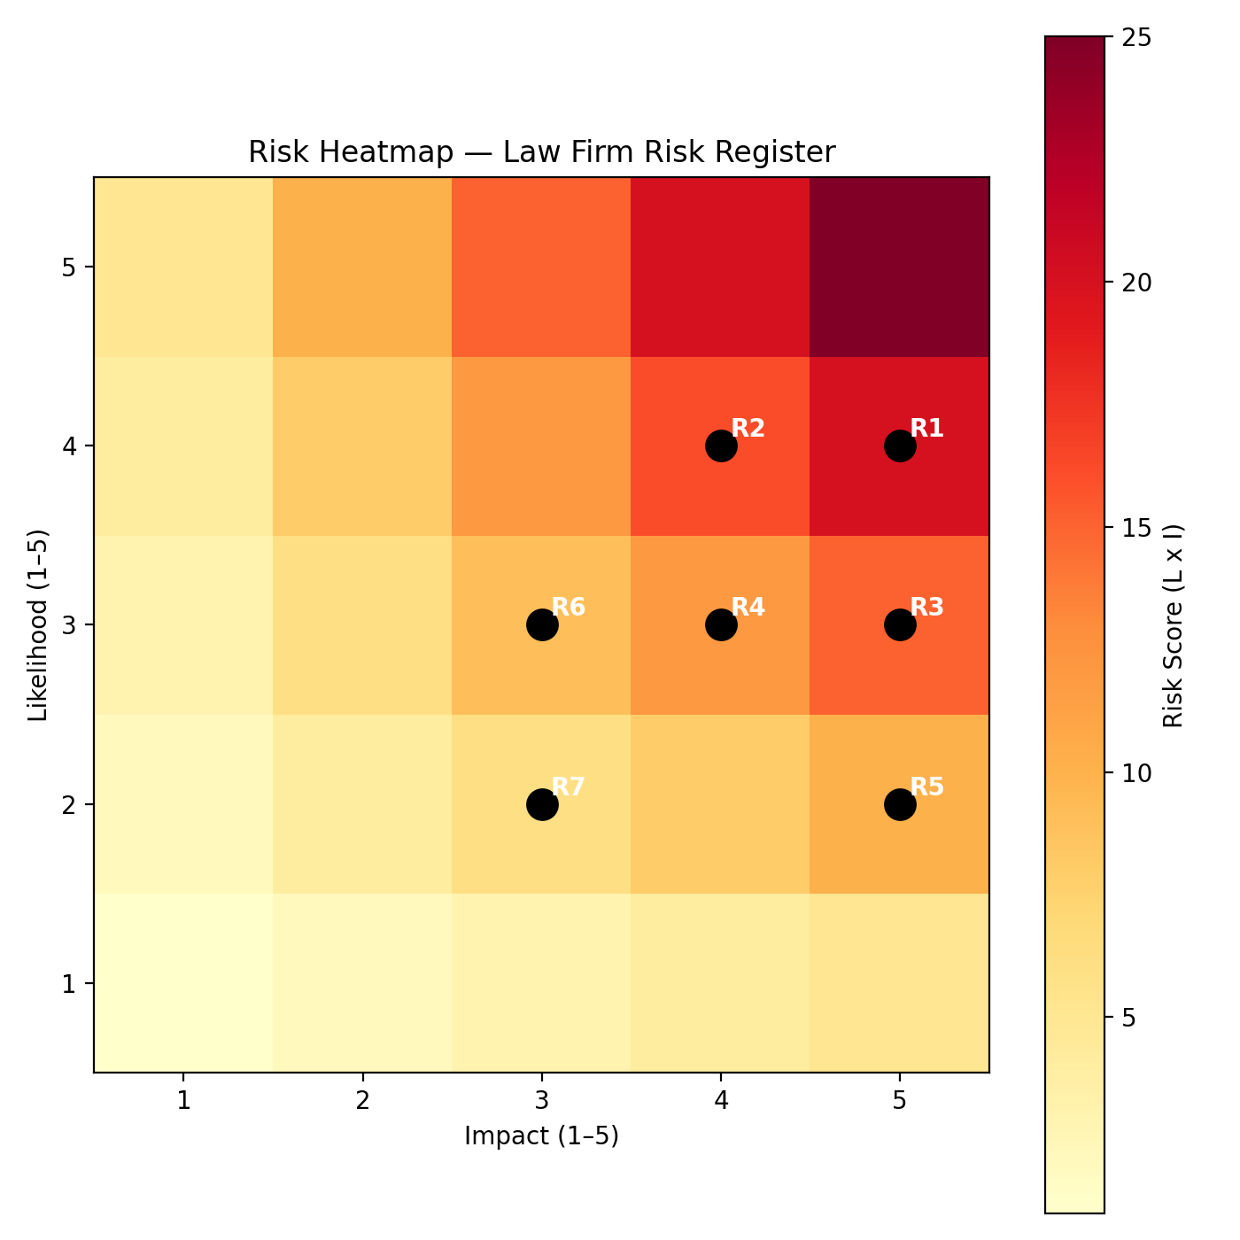
Likelihood × Impact pairs located in Sheet 6 can be used to generate a heatmap in:
- Python (matplotlib)
- Excel conditional formatting
- Power BI/Looker Studio

